- IDENTITAS
NIM : 2403001
Nama Lengkap : Siti Sa’adah
Kelas : D3 TI 2A
Program Studi : D3 TEKNIK INFORMATIKA
Jurusan : TEKNIK INFORMATIKA

- HASIL PRAKTIKUM/ TUGAS
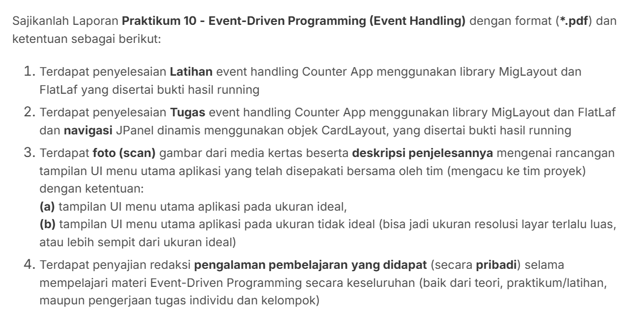
- Latihan
- Kode Program
//import java.awt.Button;
import java.awt.Dimension;
import java.awt.Font;
import javax.swing.JButton;
import javax.swing.JFrame;
import javax.swing.JLabel;
import javax.swing.JPanel;
//import javax.swing.JScrollBar;
import javax.swing.JScrollPane;
import javax.swing.SwingUtilities;
import javax.swing.UIManager;
import javax.swing.UnsupportedLookAndFeelException;
import com.formdev.flatlaf.themes.FlatMacLightLaf;
import net.miginfocom.swing.MigLayout;

public class CounterApp {
private static int nilaiCounter = 0;
public static void main(String[] args) {
try {
UIManager.setLookAndFeel(new FlatMacLightLaf());
} catch (UnsupportedLookAndFeelException e) {
e.printStackTrace();
}

SwingUtilities.invokeLater(() -> {

JFrame frame = new JFrame("Counter App Midori");
frame.setDefaultCloseOperation(JFrame.EXIT_ON_CLOSE);
frame.setPreferredSize(new Dimension(400, 300));
frame.setMinimumSize(new Dimension(200, 150));

JPanel panelCounter = new JPanel(new MigLayout("fill, wrap1", "[grow, center]", "[grow][grow]"));

JLabel labelCounter = new JLabel(nilaiCounter + "");
labelCounter.setFont(new Font("Arial", Font.BOLD, 50));
panelCounter.add(labelCounter, "bottom");

JButton buttonAdd = new JButton("+");
buttonAdd.setFont(new Font("Arial", Font.BOLD, 25));
panelCounter.add(buttonAdd, "top");

buttonAdd.addActionListener(e -> {
nilaiCounter++;
labelCounter.setText(nilaiCounter+"");
} );

JScrollPane scrollPane = new JScrollPane(panelCounter);
scrollPane.getVerticalScrollBar().setUnitIncrement(10);
scrollPane.getVerticalScrollBar().putClientProperty("JScrollBar.fastWheelScrolling", true);
scrollPane.setOpaque(true);

frame.add(scrollPane);
frame.pack();
frame.setLocationRelativeTo(null);
frame.setVisible(true);

});
}
}

- Run
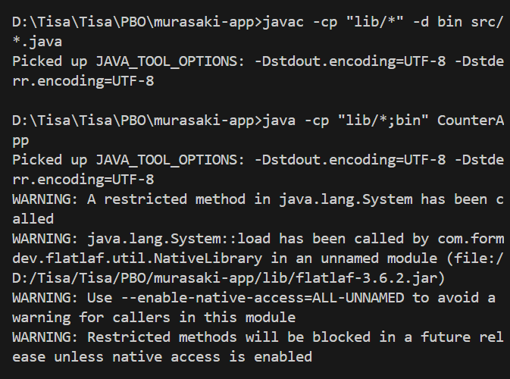

- Output
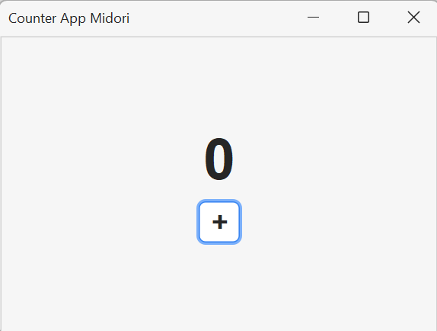

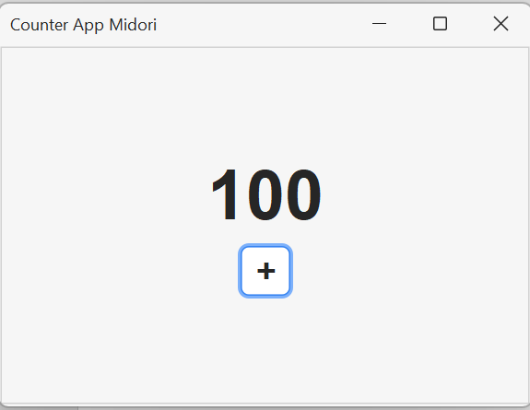

- Tugas Individu
- Percobaan 1
- Kode Program
//import java.awt.Button;
import java.awt.Dimension;
import java.awt.Font;
import javax.swing.JButton;
import javax.swing.JFrame;
import javax.swing.JLabel;
import javax.swing.JPanel;
//import javax.swing.JScrollBar;
import javax.swing.JScrollPane;
import javax.swing.SwingUtilities;
import javax.swing.UIManager;
import javax.swing.UnsupportedLookAndFeelException;
import com.formdev.flatlaf.themes.FlatMacLightLaf;
import net.miginfocom.swing.MigLayout;

public class CounterAppTugas {
private static int nilaiCounter = 0;
public static void main(String[] args) {
try {
UIManager.setLookAndFeel(new FlatMacLightLaf());
} catch (UnsupportedLookAndFeelException e) {
e.printStackTrace();
}

SwingUtilities.invokeLater(() -> {

JFrame frame = new JFrame("Counter App Midori");
frame.setDefaultCloseOperation(JFrame.EXIT_ON_CLOSE);
frame.setPreferredSize(new Dimension(400, 300));
frame.setMinimumSize(new Dimension(200, 150));

JPanel panelCounter = new JPanel(new MigLayout("fill, wrap1", "[grow, center]", "[grow][grow]"));

JLabel labelCounter = new JLabel(nilaiCounter + "");
labelCounter.setFont(new Font("Arial", Font.BOLD, 50));
panelCounter.add(labelCounter, "bottom");

JPanel panelButtons = new JPanel(new MigLayout("insets 0", "[]10[]", "[]"));

JButton buttonAdd1 = new JButton("-");
buttonAdd1.setFont(new Font("Arial", Font.BOLD, 25));
//panelCounter.add(buttonAdd1, "top");
panelButtons.add(buttonAdd1);

buttonAdd1.addActionListener(e -> {
nilaiCounter--;
labelCounter.setText(nilaiCounter+"");
} );

JButton buttonAdd = new JButton("+");
buttonAdd.setFont(new Font("Arial", Font.BOLD, 25));
//panelCounter.add(buttonAdd, "top");
panelButtons.add(buttonAdd);

buttonAdd.addActionListener(e -> {
nilaiCounter++;
labelCounter.setText(nilaiCounter+"");
} );

panelCounter.add(panelButtons, "top");

JScrollPane scrollPane = new JScrollPane(panelCounter);
scrollPane.getVerticalScrollBar().setUnitIncrement(10);
scrollPane.getVerticalScrollBar().putClientProperty("JScrollBar.fastWheelScrolling", true);
scrollPane.setOpaque(true);

frame.add(scrollPane);
frame.pack();
frame.setLocationRelativeTo(null);
frame.setVisible(true);

});
}
}

- Run
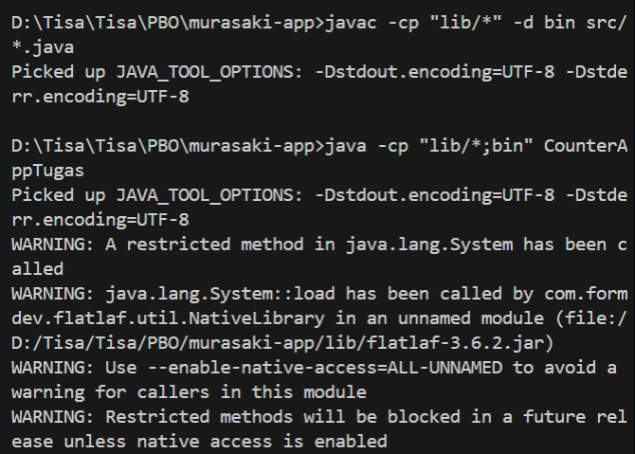

- Output
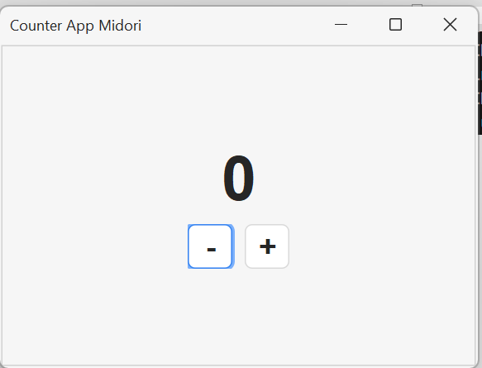

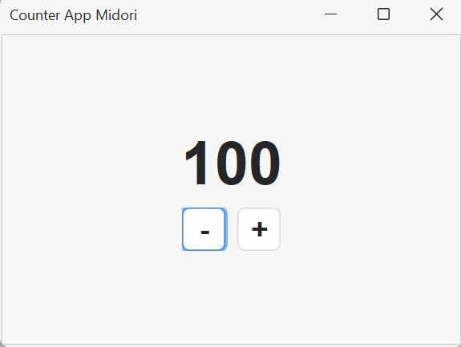
- Percobaan 2
- Kode Program
//import java.awt.Button;
import java.awt.Dimension;
import java.awt.Font;
import javax.swing.JButton;
import javax.swing.JFrame;
import javax.swing.JLabel;
import javax.swing.JPanel;
//import javax.swing.JScrollBar;
import javax.swing.JScrollPane;
import javax.swing.SwingUtilities;
import javax.swing.UIManager;
import javax.swing.UnsupportedLookAndFeelException;
import com.formdev.flatlaf.themes.FlatMacLightLaf;
import net.miginfocom.swing.MigLayout;

public class CounterAppTugas2 {
private static int nilaiCounter = 0;
public static void main(String[] args) {
try {
UIManager.setLookAndFeel(new FlatMacLightLaf());
} catch (UnsupportedLookAndFeelException e) {
e.printStackTrace();
}

SwingUtilities.invokeLater(() -> {

JFrame frame = new JFrame("Counter App Midori");
frame.setDefaultCloseOperation(JFrame.EXIT_ON_CLOSE);
frame.setPreferredSize(new Dimension(400, 300));
frame.setMinimumSize(new Dimension(200, 150));

JPanel mainPanel = new JPanel(new java.awt.CardLayout());

JPanel panelCounter = new JPanel(new MigLayout("fill, wrap1", "[grow, center]", "[grow][grow]"));

JLabel labelCounter = new JLabel(nilaiCounter + "");
labelCounter.setFont(new Font("Arial", Font.BOLD, 50));
panelCounter.add(labelCounter, "center");

JPanel panelButtons = new JPanel(new MigLayout("insets 0", "[]10[]", "[]"));

JButton buttonAdd1 = new JButton("-");
buttonAdd1.setFont(new Font("Arial", Font.BOLD, 25));
//panelCounter.add(buttonAdd1, "top");
panelButtons.add(buttonAdd1);

buttonAdd1.addActionListener(e -> {
nilaiCounter--;
labelCounter.setText(nilaiCounter+"");
} );

JButton buttonAdd = new JButton("+");
buttonAdd.setFont(new Font("Arial", Font.BOLD, 25));
//panelCounter.add(buttonAdd, "top");
panelButtons.add(buttonAdd);

buttonAdd.addActionListener(e -> {
nilaiCounter++;
labelCounter.setText(nilaiCounter+"");
} );

panelCounter.add(panelButtons, "center");

JButton buttonNext = new JButton(">");
buttonNext.setFont(new Font("Arial", Font.BOLD, 25));
panelCounter.add(buttonNext, "right, bottom");

mainPanel.add(panelCounter, "page1");

JScrollPane scrollPane = new JScrollPane(panelCounter);
scrollPane.getVerticalScrollBar().setUnitIncrement(10);
scrollPane.getVerticalScrollBar().putClientProperty("JScrollBar.fastWheelScrolling", true);
scrollPane.setOpaque(true);

frame.add(scrollPane);
frame.pack();
frame.setLocationRelativeTo(null);
frame.setVisible(true);

});
}
}

- Run
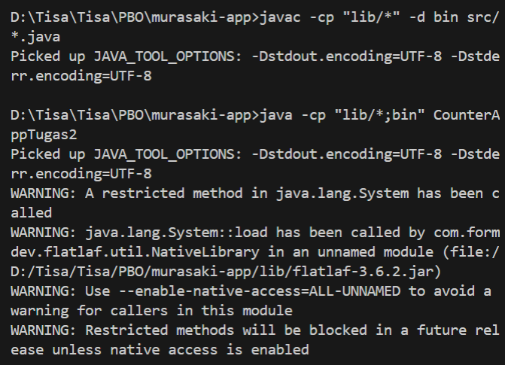

- Output
Button “>” belum berfungsi.
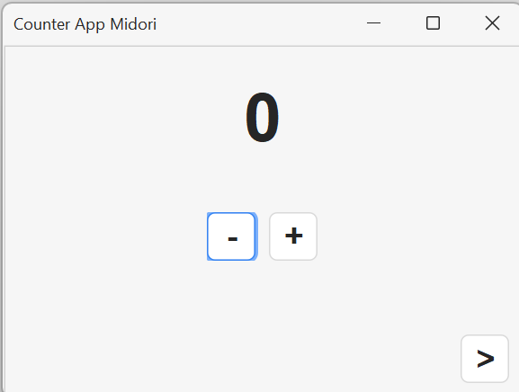

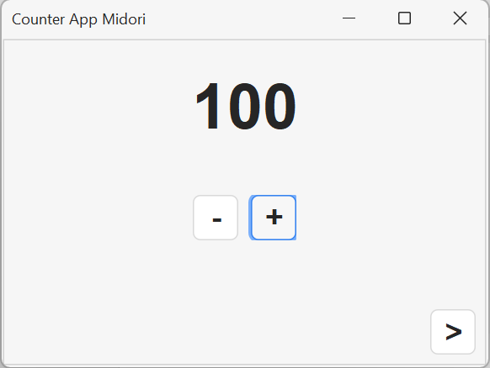
- Percobaan 3 ( Hasil Akhir)
- Kode Program
//import java.awt.Button;
import java.awt.CardLayout;
import java.awt.Dimension;
import java.awt.Font;
import javax.swing.JButton;
import javax.swing.JFrame;
import javax.swing.JLabel;
import javax.swing.JPanel;
//import javax.swing.JScrollBar;
import javax.swing.JScrollPane;
import javax.swing.SwingUtilities;
import javax.swing.UIManager;
import javax.swing.UnsupportedLookAndFeelException;
import com.formdev.flatlaf.themes.FlatMacLightLaf;
import net.miginfocom.swing.MigLayout;

public class CounterAppTugas3 {
private static int nilaiCounter = 0;
public static void main(String[] args) {
try {
UIManager.setLookAndFeel(new FlatMacLightLaf());
} catch (UnsupportedLookAndFeelException e) {
e.printStackTrace();
}

SwingUtilities.invokeLater(() -> {

JFrame frame = new JFrame("Counter App Midori");
frame.setDefaultCloseOperation(JFrame.EXIT_ON_CLOSE);
frame.setPreferredSize(new Dimension(400, 300));
frame.setMinimumSize(new Dimension(200, 150));

JPanel mainPanel = new JPanel(new CardLayout());

JPanel panelCounter = new JPanel(new MigLayout("fill, wrap1", "[grow, center]", "[grow][grow]"));

JLabel labelCounter = new JLabel(nilaiCounter + "");
labelCounter.setFont(new Font("Arial", Font.BOLD, 50));
panelCounter.add(labelCounter, "center");

JPanel panelButtons = new JPanel(new MigLayout("insets 0", "[]10[]", "[]"));

JButton buttonAdd1 = new JButton("-");
buttonAdd1.setFont(new Font("Arial", Font.BOLD, 25));
//panelCounter.add(buttonAdd1, "top");
panelButtons.add(buttonAdd1);

buttonAdd1.addActionListener(e -> {
nilaiCounter--;
labelCounter.setText(nilaiCounter+"");
} );

JButton buttonAdd = new JButton("+");
buttonAdd.setFont(new Font("Arial", Font.BOLD, 25));
//panelCounter.add(buttonAdd, "top");
panelButtons.add(buttonAdd);

buttonAdd.addActionListener(e -> {
nilaiCounter++;
labelCounter.setText(nilaiCounter+"");
} );

panelCounter.add(panelButtons, "center");

JButton buttonNext = new JButton(">");
buttonNext.setFont(new Font("Arial", Font.BOLD, 25));
panelCounter.add(buttonNext, "right, bottom");

mainPanel.add(panelCounter, "page1");

JPanel panelResult = new JPanel(new MigLayout("fill, wrap1", "[grow, center]", "[grow][grow][grow]"));

JLabel labelInfo = new JLabel("Nilai terakhir Anda adalah");
labelInfo.setFont(new Font("Arial", Font.PLAIN, 18));
panelResult.add(labelInfo, "center");

JLabel labelHasil = new JLabel("0");
labelHasil.setFont(new Font("Arial", Font.BOLD, 50));
panelResult.add(labelHasil, "center");

JButton buttonBack = new JButton("<");
buttonBack.setFont(new Font("Arial", Font.BOLD, 25));
panelResult.add(buttonBack, "left, bottom");

mainPanel.add(panelResult, "page2");

buttonNext.addActionListener(e -> {
labelHasil.setText(String.valueOf(nilaiCounter));
CardLayout cl = (CardLayout) mainPanel.getLayout();
cl.show(mainPanel, "page2");
} );

buttonBack.addActionListener(e -> {
CardLayout cl = (CardLayout) mainPanel.getLayout();
cl.show(mainPanel, "page1");
});

JScrollPane scrollPane = new JScrollPane(mainPanel);
scrollPane.getVerticalScrollBar().setUnitIncrement(10);
scrollPane.getVerticalScrollBar().putClientProperty("JScrollBar.fastWheelScrolling", true);
scrollPane.setOpaque(true);

frame.add(scrollPane);
//frame.add(mainPanel);
frame.pack();
frame.setLocationRelativeTo(null);
frame.setVisible(true);

});
}
}

- Run
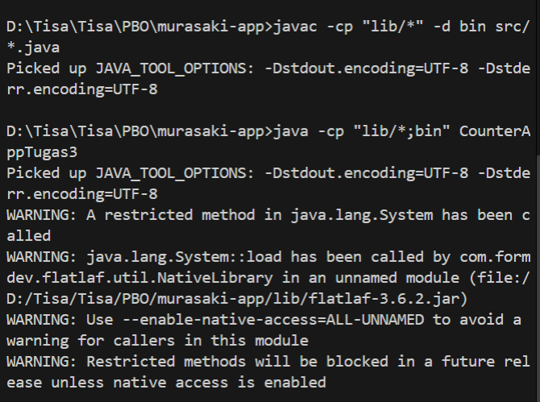

- Output
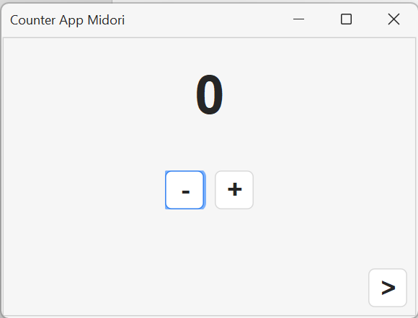

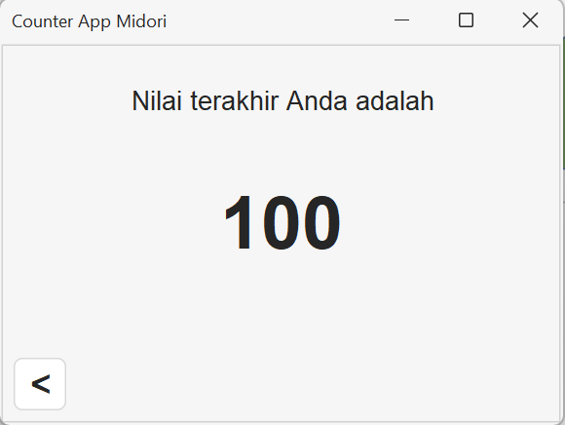
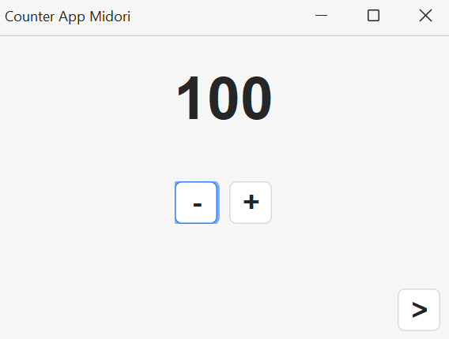
- Tugas Kelompok (Gambar)
- Tampilan Ideal
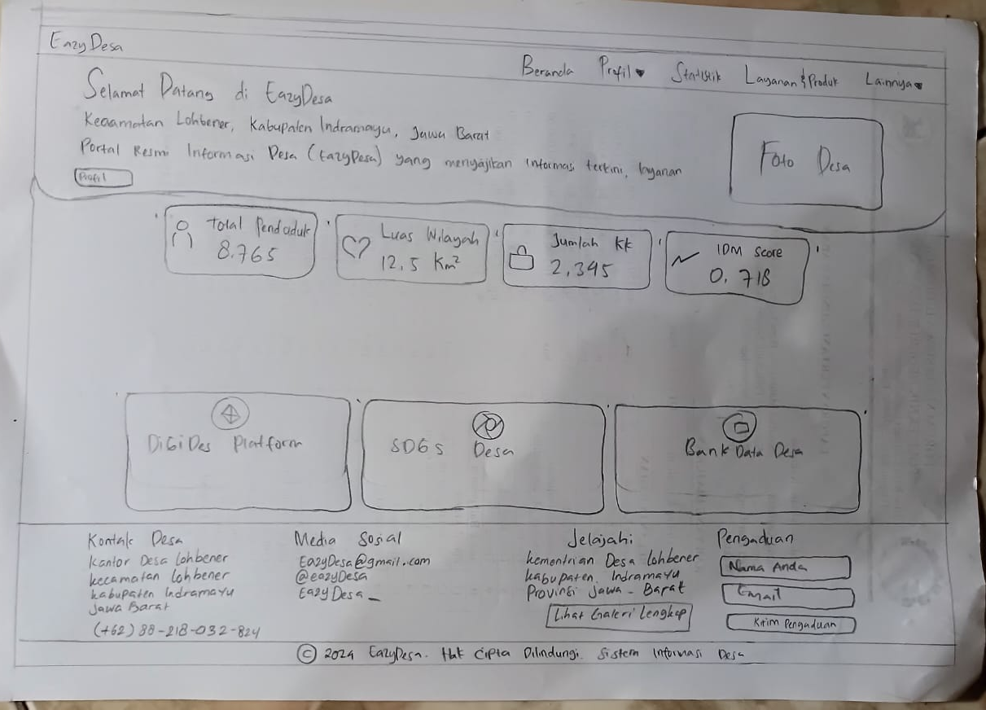

- Tampilan Non-Ideal
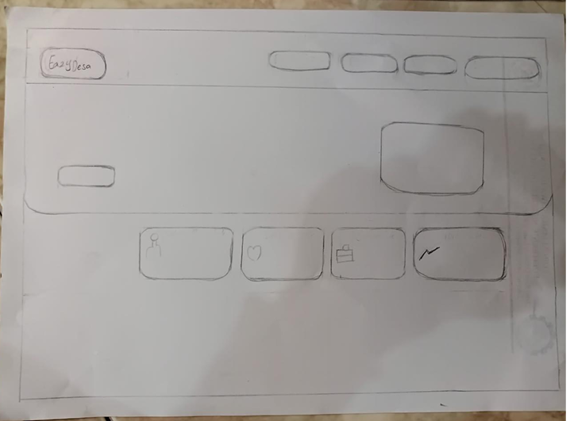

- Pengalaman Pembelajaran
Pada materi Event-Driven Programing ini kita mempelajari cara membuat perangkat lunak yang terpicu oleh event yang berbeda beda. Yaitu :
- Event Source
- Event Trigger
- Event Object
- Event Dispatching
- Event Listener
- Event Handler
Selain itu kategori Event Handling terbagi menjadi 3 :
- Semantic
- Low-level
- Specific

- Link Repository
https://github.com/Tisa-34/murasaki-app

